Difference between cloud computing and virtualisation

|  |  |  |
| --- | --- | --- |
|  | Cloud computing | Virtualisation |
| Scalability | Cloud can be extended as much as you want  Eg: pay as you go | Virtual Machine configuration limits it’s scalabitiy  Eg: there is limitation |
| Quick setup | Setting up cloud is very tedious task | It is very simple to setup virtual env |
| Flexibility | It is very flexible for user access. User can access it’s cloud from any location with internet | Proper authentication is required before accessing the virtual machines |
| Service type | IAAS | SAAS |
| Dedicated hardware | Multiple hardware creates cloud computing | Dedicated hardware required for multiple virtual machine  Eg: single system – multiple os |
| Integration | Cloud integration allows future expansion of user, application etc | Virtuael integration allows expansion of new machines within the same infrastructure |
| Dependency | Multiple user can access the network using same link | Multiple OS can be installed on single server/computer |
| Accessibility | It can be accessed from all over the world (internet based cloud) | Proper permissions are required for accessing from outside network |
| Disaster recovery | Not depend upon one machine | Single machiner failure can break done multiple virtual machine |
| Types | Private & public cloud | Hardware virtualisation and application virtualisation |

**VM Provisioning**

Server provisioning is defining server’s configuration based on the user’s requirements

* Hardeware – CPU, RAM, storage, network, etc
* OS
* Application

**VM provisioning life cycle**

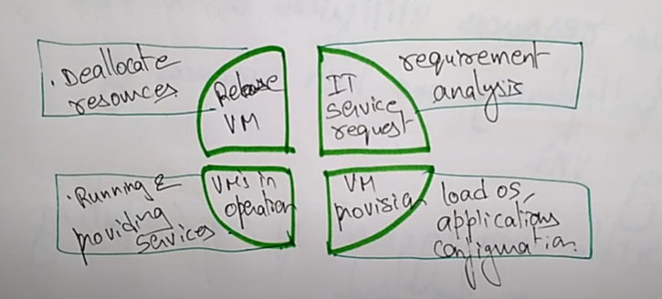

1. IT service request
2. VM provision
3. Vm operation
4. Release VM

**VM migration**

Needs for virtual machine migrations from one system to another

1. Upgrading
2. Balancing resources
3. Vm failures
4. Meet SLA

**VM migration techniques**

1. Live/hot migration
2. Regular/cold migration

**Live/host migration**

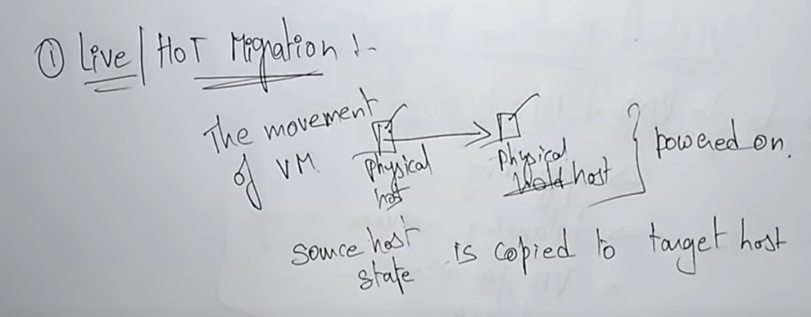

**Regular/cold migrations**

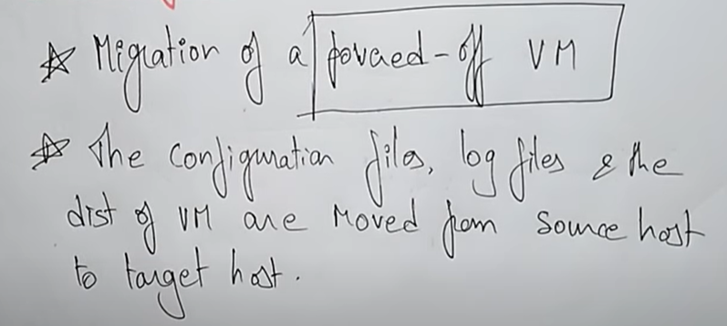

|  |  |
| --- | --- |
| Hot /live | Regular/ cold |
| VM is powered on | VM IS powered off |
| Needs shared storage | VM are not required to be shared storage |
| CPU checks | No Cpu checks |
| Shortage time is very small | Shortage time is large |

**Virtualised environment characteristics**

7 characteristics of

1. Security isolation
2. Resource isolation
3. Efficiency
4. Availability
5. Serviceability
6. Flexibility
7. Agility
8. Security isolation
   1. Shared environment relied on physical separation to enforce security
   2. **Access control mechanisms** and **encryption play** a key part
   3. Existing security policies may need to be re-written
9. Resource isolation
   1. Virtualisation environment used **dedicated hardware** to guarantee access to resources
   2. Shared environment allow better use of separate capacity
   3. **Word load** should still be guaranteed minimum resource level
10. Workload efficiency
    1. Virtualisation usually introduces overhead
       1. Hypervisor overhead
       2. Virtualized resource overhead
       3. o/s overhead
    2. virtualisation is sometimes used to address scalability issues either at hardware, os or application level

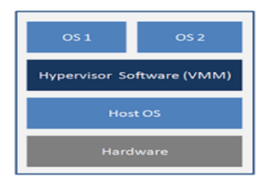

1. Availability
   1. Consolidated workloads suffer a higher impact due to infrastructure failure
   2. An **individual workload** within pool may not required high availability , but combination of **several workloads** does
2. Serviceability
   1. Consolidate workload suffer a higher impact due to infratsruture maintenance
   2. Negotiation a join outage window across multiple business owners can be extremeluy difficult
   3. Number of service events that require an outage should be as low as possible
   4. In cases where an outage is unavoidable, workloads, should be able to move with minimum of disruption
3. Flexibility
   1. Workloads typically have resource utlisation patterns that very overtime. They may also grow or shrink over longer periods of time
   2. It is therefore important to be able to alter the resource allocation of these workloads
   3. Ideally these should be automatica dynamic and immediate. So that idle workload do not reserve resources, and busy workloads can get them
4. Agility
   1. In consolidated infratstruce it is often useful to move workloads, between servers withinin resource pool
   2. Agility is measure of workload migration between physical servers and takes into account
      1. Ease/ simplicity of migration
      2. Impact of migration
      3. Speed of migration

**Levels of virtualisation**